Episode 538: Electron scattering

This could follow work on Rutherford scattering, where alpha particles are used to identify the nucleus as the region of the atoms containing all the positive charge and most of the mass. Calculation of closest approach of alpha particles gives an estimate of nuclear size, but more direct experimental evidence is given by scattering of electrons.
Lesson Summary
- Student experiment: An optical analogue (10 minutes)
- Discussion: Diffraction graphs (10 minutes)
- Worked example: Calculating nuclear diameter (10 minutes)
- Student questions: Further examples (20 minutes)

Student experiment: An optical analogue
When waves pass through a collection of spheres, which look like circles to the oncoming waves, they diffract around them in the same way as through holes of the same size. This means that they produce a diffraction pattern with a minimum at roughly the angle given by the single-slit diffraction equation sin( θ ) = λ/d (it should really be sin( θ ) = 1.22 λ/d for a circle; you could use that form, but the familiar equation is close enough here).
Look at a point source of light (a small circuitry lamp is fine) through a pinhole made in aluminium foil – the smaller the hole the better, so use a fine sewing needle or else pull thin copper wire until it snaps, and push the work-hardened tip through the aluminium foil. A diffraction pattern consisting of a circle with a surrounding ring (more than one if you’re lucky) should be visible. If you look at the point source through a microscope slide dusted with lycopodium powder (cornflour will work, but is not as good, because the particle sizes vary more) you see a similar pattern. You may like to refer to the halo seen around the Moon in the winter, which is due to similar scattering by ice crystals in the upper atmosphere.
The point here is that waves encountering round (spherical) objects will give a diffraction pattern, involving a central maximum, and then a minimum before the secondary maximum of the surrounding ring.

Discussion: Diffraction graphs
The graph below compares a typical electron diffraction pattern with the Rutherford alpha -scattering pattern and the single slit pattern. Show this graph, and identify the differences.
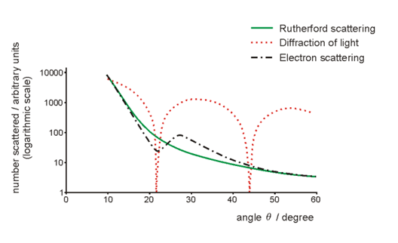
Episode 538-1: Rutherford alpha-scattering pattern & single slit pattern (Word, 26 KB) - see end of document

The electron scattering clearly shows features of both Rutherford scattering (due to electrostatic interaction: the fact that the force is attractive rather than repulsive is not important) and diffraction. Concentrating on the minimum, it suggests that the nucleus is behaving as a circular object of diameter d.

Worked examples: Calculating nuclear diameter
The nuclear diameter d can be calculated from the electron scattering data. If your students can cope with the maths, you can work through a sample calculation.
(The virtue of the approach is not that students should be able to reproduce the mathematics, but that they should be able to see that a systematic application of the mathematics related to diffraction and the wave nature of the electron can give the size of the nucleus. Note: The calculation assumes that the rest energy of the electron is negligble.)
energy of electron = 100 MeV
energy of electron = 100 × 10⁶ V × 1.6 × 10⁻¹⁹ C
energy of electron = 1.6 × 10⁻¹¹ J
electron momentum, p
p = E/c
p = 1.6 × 10⁻¹¹ J/3 x 10⁸ m s⁻¹
momentum = 5.3 × 10⁻²⁰ kg m s⁻¹
de Broglie relationship, λ = h/p
λ = 6.6 × 10⁻³⁴ J s⁻¹5.3 × 10⁻²⁰ kg m s⁻¹
wavelength = 1.2 × 10⁻¹⁴ m
The first diffraction minimum occurs at about 22 ° , so using the single slit diffraction equation
sin( θ ) = λ/d
rearrange this to get
d = λ/sin(θ)
d = 1.2 × 10⁻¹⁴ m/sin(22)
nuclear diameter = 3.3 × 10⁻¹⁴ m

Student questions: Further examples
A structured question will allow your students to follow through this logic for themselves. It should be covered here if you did not do so in Episode 522.
Episode 522-6: Electrons measure the size of nuclei (Word, 42 KB) - see end of document

Episode 538-1: Rutherford alpha -scattering pattern and the single slit pattern

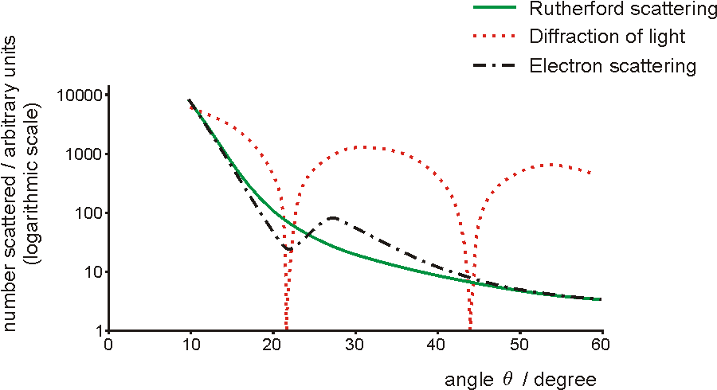

Practical advice
The graph is reproduced here for use in the classroom.

Episode 522-6: Electrons measure the size of nuclei

Scattering by small particles
Hold a glass plate smeared with a little milk, or dusted with lycopodium powder, in front of a point source of light and you may see rings of light round the source. The photons are diffracted by globules of fat in the milk or by the lycopodium spores.
Similarly to diffraction by a small hole of diameter d, there is a first minimum intensity at an angle θ of order of magnitude given by sin θ = λ / d. (For circular objects or apertures a more exact expression is sin θ = 1.22 λ / d.)
Angles and wavelengths
1. Show that if you see a first dark ring at θ = 30°, the circular objects have diameter approximately twice the wavelength.

2. Use the expression sin θ = 1.22 λ / d to find the angle of the first dark ring for particles four wavelengths in diameter.

Wavelengths for electrons
The de Broglie wavelength λ of an electron of momentum p is given by λ = h / p, where h is the Planck constant, 6.6 × 10–34 J Hz–1.
Since the rest energy of an electron is 0.5 MeV, at energies of hundreds of MeV, the rest energy can be ignored as part of the total energy E. In this case the momentum p is given to a good approximation by p = E / c.
3. An electron has an energy of 100MeV. Calculate the energy of the electron in joules.
(take 1 eV = 1.6 × 10–19 J).

4. Use the value of the energy from question 3 to calculate the momentum of the electron.

5. Use the value of the momentum from question 4 to calculate the de Broglie wavelength of 100 MeV electrons.

6. The radius of a single proton or neutron is of the order 1.2 × 10–15 m. What approximately is the ratio of the wavelength of the electrons to the diameter of a proton or neutron?

7. Using the relations p = E / c and λ = h / p show that the de Broglie wavelength is inversely proportional to the energy E.

8. Use the result of question 7 and the answer to question 5 to show that the de Broglie wavelength for 400 MeV electrons is about 3.0 × 10–15 m.

Electron scattering by nuclei
You have seen that electrons of a few hundred MeV have de Broglie wavelengths comparable to the diameter of a nucleus. Suppose that in an experiment a beam of 400 MeV electrons is scattered by carbon-12 nuclei. The angle θ at which the scattering is first a minimum is 42°, for which sin θ = 0.67.
9. Calculate the ratio λ / d of the de Broglie wavelength to the diameter of a carbon-12 nucleus.

10. Use the de Broglie wavelength of 400 MeV electrons from question 8 to show that the radius of a carbon-12 nucleus is about 2.7 × 10–15 m.

11. You might expect the volume occupied by the 12 nucleons of carbon-12 to be 12 times the volume occupied by one nucleon. The radius of a nucleon is about 1.2 × 10–15 m. Show that the ratio of the volumes is about 12 (expect some rounding error in these figures).

12. A uranium-238 nucleus has a radius of about 7.4 × 10–15 m. What roughly would be a good energy of electrons to use to determine its radius by scattering?

Hints
1. sin 30° = ½.
2. Substitute in the expression for sin q.
3. The conversion factor is equal to the magnitude of the charge on the electron.
4. Use p = E/c.
5. Use λ = h/p.
6. Remember that the diameter = 2 x radius.
7. Substitute p = E/c for p.
8. Scale down the wavelength in proportion to the increase in energy.
9. Obtain the ratio λ/d from the value of sin q.
10. Remember the radius is half the diameter.
11. The ratio of the volumes is the cube of the ratio of the radii.
12. Choose a reasonable angle, say 30°.

Practical advice
These questions lead students through a numerical example of the measurement of nuclear dimensions by electron scattering, using the diffraction of the electrons to obtain the scale. Many students will require help with the powers of ten involved, and the conversion between electron volts and energy in joules.
The questions are intended primarily as ‘learning questions’ to be gone through slowly. Some students may profit from tackling them alone, but most will need to be taken through them, and have the general message pointed out for them.

Social and human context
To measure these tiny distances needed a linear accelerator a few kilometres in length. Large energies to measure small dimensions are expensive.

Answers and worked solutions
1. sin 30° = ½ = λ/d approximately.

2.
The angle whose sin is 0.305 is 17.8°.

3.

4.

5.

6. Ratio of wavelength to radius = 12 x 10^{–15} m / 1.2 x 10^{–15} m = 10;
ratio of wavelength to diameter = 5.

7. Substitute
in
gives

8. From
λ is inversely proportional to E. Since λ for 100 MeV is 12 x 10^{–15} m then λ for 400 MeV is 3 x 10^{–15} m.

9. Since sin θ = 0.67, then 0.67 = 1.22 λ / d, and λ / d = 0.55.

10. Since λ for 400 MeV is 3 x 10^{–15} m, and λ / d = 0.55, then d = 5.5 x 10^{–15} m and r = 2.7 x 10^{–15} m.

11. (2.7/1.2)³ = 11.4. It would be closer to 12 but for rounding errors.

12. Diameter of the uranium-238 nucleus = 15 x 10^{–15} m. Choosing λ  = 2d gives
λ = 30 x 10^{–15} m, about five times the wavelength of 400 MeV electrons (3 x 10^{–15} m). So scale down energy by a factor 5, to say 80 MeV.

External reference
This activity is taken from Advancing Physics chapter 17, 90S

